11. ReactJS-HOL
Creating React App : npx create-react-app eventexamplesapp

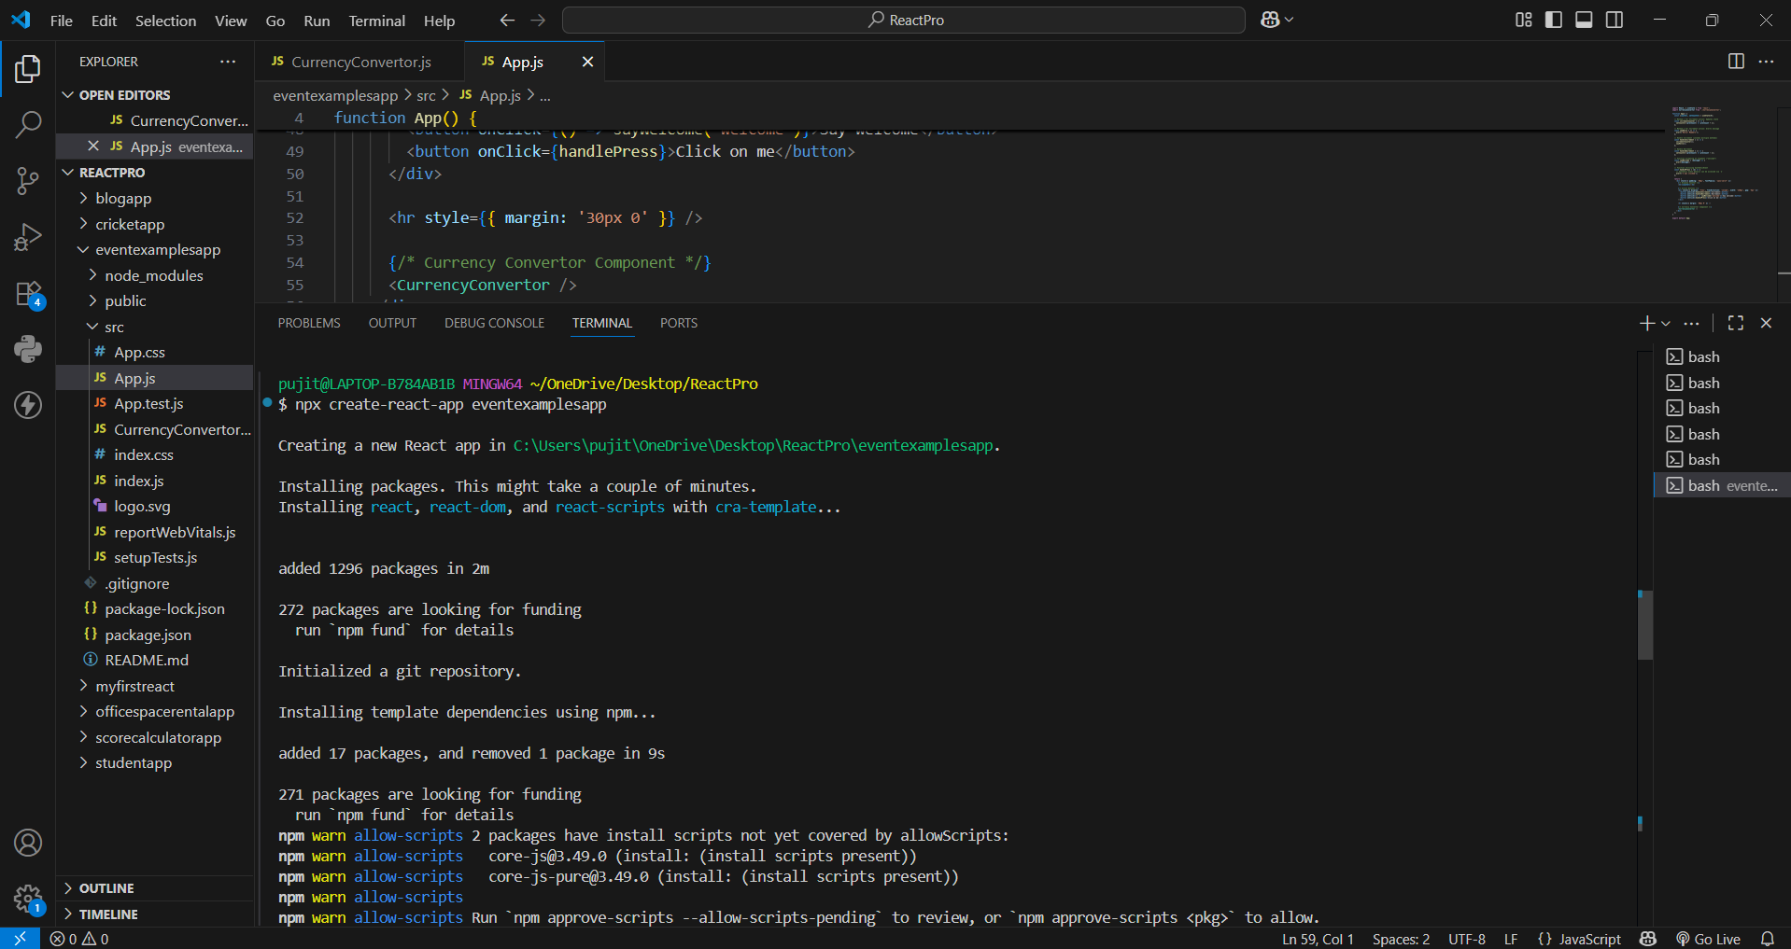
CurrencyConvertor.js
import React, { useState } from 'react'
function CurrencyConvertor() {
const [amount, setAmount] = useState('');
const [currency, setCurrency] = useState('');
const handleSubmit = (e) => {
e.preventDefault(); // Prevents default form refresh behavior

// If currency entered is Euro (case-insensitive), multiply by 80
if (currency.trim().toLowerCase() === 'euro') {
const convertedAmount = Number(amount) * 80;
alert(`Converting to Euro Amount is ${convertedAmount}`);
} else {
alert(`Entered Currency: ${currency}, Amount: ${amount}`);
}
};

return (
<div style={{ marginTop: '20px' }}>
<h1 style={{ color: 'green' }}>Currency Convertor!!!</h1>
<form onSubmit={handleSubmit}>
<div style={{ marginBottom: '10px' }}>
<label style={{ marginRight: '10px' }}>Amount:</label>
<input
type="text"
value={amount}
onChange={(e) => setAmount(e.target.value)}
/>
</div>
<div style={{ marginBottom: '10px' }}>
<label style={{ marginRight: '10px' }}>Currency:</label>
<input
type="text"
value={currency}
onChange={(e) => setCurrency(e.target.value)}
/>
</div>
<button type="submit" style={{ marginLeft: '60px' }}>
Submit
</button>
</form>
</div>
);
}

export default CurrencyConvertor;
App.js :
import React, { useState } from 'react';
import CurrencyConvertor from './CurrencyConvertor';

function App() {
const [counter, setCounter] = useState(0);

// Method 1 for Increment action: Updates state
const incrementCounter = () => {
setCounter((prevCount) => prevCount + 1);
};

// Method 2 for Increment action: Alerts message
const sayHello = () => {
alert('Hello! Member1');
};

// Handle Increment (invokes multiple methods)
const handleIncrement = () => {
incrementCounter();
sayHello();
};

// Handle Decrement
const handleDecrement = () => {
setCounter((prevCount) => prevCount - 1);
};

// Function accepting an argument ("welcome")
const sayWelcome = (message) => {
alert(message);
};

// Function utilizing SyntheticEvent
const handlePress = (e) => {
// Synthetic event details can be accessed via `e`
alert('I was clicked');
};

return (
<div style={{ padding: '20px', fontFamily: 'sans-serif' }}>
{/* Display Counter */}
<h2>{counter}</h2>

{/* Action Buttons */}
<div style={{ display: 'flex', flexDirection: 'column', width: '120px', gap: '5px' }}>
<button onClick={handleIncrement}>Increment</button>
<button onClick={handleDecrement}>Decrement</button>
<button onClick={() => sayWelcome('welcome')}>Say welcome</button>
<button onClick={handlePress}>Click on me</button>
</div>

<hr style={{ margin: '30px 0' }} />

{/* Currency Convertor Component */}
<CurrencyConvertor />
</div>
);
}

export default App;
Running on localhost 3000 :

